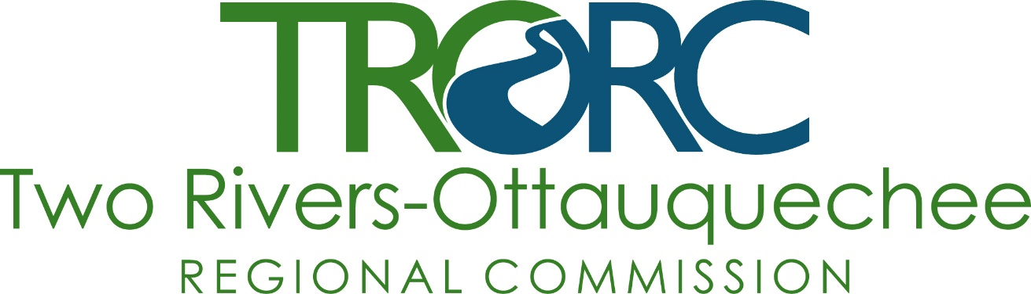
REQUEST FOR PROPOSALS
for
COMMUNICATION SERVICES
INTRODUCTION
Two-Rivers Ottauquechee Regional Commission (TRORC) is a regional planning commission serving 30 towns and over 50,000 people in Addison, Orange, Rutland, and Windsor Counties in East-Central Vermont.
TRORC has a robust website, and a growing library of online videos, as well as a marginal Facebook presence. We do not have a Linkedin or other digital presence.
TRORC is seeking a qualified consultant to develop a internet/social media outreach plan that will help us reach our audience of residents of the region, local officials, and businesses in (or interested in locating in) the region. Outreach efforts are aimed to inform the general populace about planning issues, create greater participation in current projects, let local officials know of trainings and provide those trainings online, and create a better understanding of planning in general and greater recognition of TRORC as a valuable resource. In particular, we are seeking proposals that will help us discover the differences and bridge the gap in social media usage among the age/income/education groups in the region. We seek to find the best and most efficient methods and platforms through which we can reach the citizens of our region. The approximate budget/request for this project is between $5,000 and $10,000.
NEEDS ASSESSMENT
We require the following social media services:
- Usage analytics from our region
- Regional social media strategy
- Social media training for staff
- Social media marketing services
REQUEST
Interested parties shall provide a proposal consisting of the following documents and information:
- A signed cover letter by a principal in the firm explaining your firm or team’s interest in the project, along with how your knowledge, experience, and skills align with the scope of the work. The cover letter must also acknowledge that you have, or will have, the required insurance coverages (see below).
- A brief technical proposal of specific services that you will provide with estimated billing rates, as they relate to social media strategy. A proposal will be scored higher if it demonstrates that a consultant has experience assisting a diverse range of organizations, including public-facing organizations and those with little to no prior social media experience or presence.
- At least two work sample(s) from a project of a similar scope. Please provide client company name, primary contact name, phone number, and email address.
Please email all forms by October 14, 2022 to Executive Director Peter Gregory pgregory@trorc.org. Applicants will be informed of their proposal status by October 31, 2022.
EVALUATION
For proposal evaluation, the following scoring system will be used:
- - 5 as “Excellent” / “More than fully compliant/innovative”
- - 4 as “Good” / “Fully compliant”
- - 3 as “Satisfactory” / “Compliant”
- - 2 as “Acceptable” / “Almost compliant”
- - 1 as “Unsatisfactory” / “Poorly compliant”
- - 0 as “Major concerns” / “Non-compliant”

Minority and Women-owned businesses are encouraged to apply.
Questions can be directed to Peter Fellows, 802-457-3188 or pfellows@trorc.org.

